(Approx. 185 words)

Acronis True Image Backup
Reviewed February 2017
By George Harding, Treasurer, Tucson Computer Society
www.aztcs.org
georgehardingsbd (at) earthlink.net

There are many programs for saving your vital data and programs; some are separate programs and some are built into the operating system. One which has been around for many years is Acronis, a program provided by a Swiss company. Acronis has had a backup program for many operating systems, providing new versions as operating systems have changed. The result is a proliferation of different versions, each doing essentially the same job. The most recent version, however, does backup and considerably more. The newest version, with just-released True Image New Generation features, offers:
- Protection from ransomware
- Notary which assures that data you’ve backed up is authentic and unchanged
- Security which makes sure that data is secure against intervention or alteration
- Cloud backup and
- Mobile backup

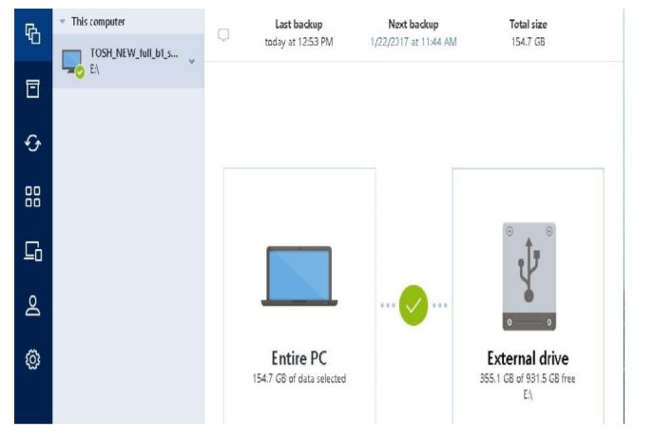
This program does a lot and yet it is easy to use. A free trial is available at www.acronis.com.

Acronis True Image New Generation
Price $80 for one year
Check out user group ½ price from UG Relations: gene or linda (at) ugr7.com

